* 1. It can be done a lot of ways I'm not married to our layout but I'd say changes should be motivated by UX needs so unless you see any specific problem with how it is I wouldn't prioritize changing it, the other notes are more critical.
     1. I think this change makes sense but I think there is an ‘easier’ way of doing it. We could have the chart scroll down the left side.
     2. So that big black area that has no info in it, now would have the chart with the info that lets the user fill out their orders.
     3. If this isn’t a huge ask I think we should consider doing this before moving to beta.

Now:

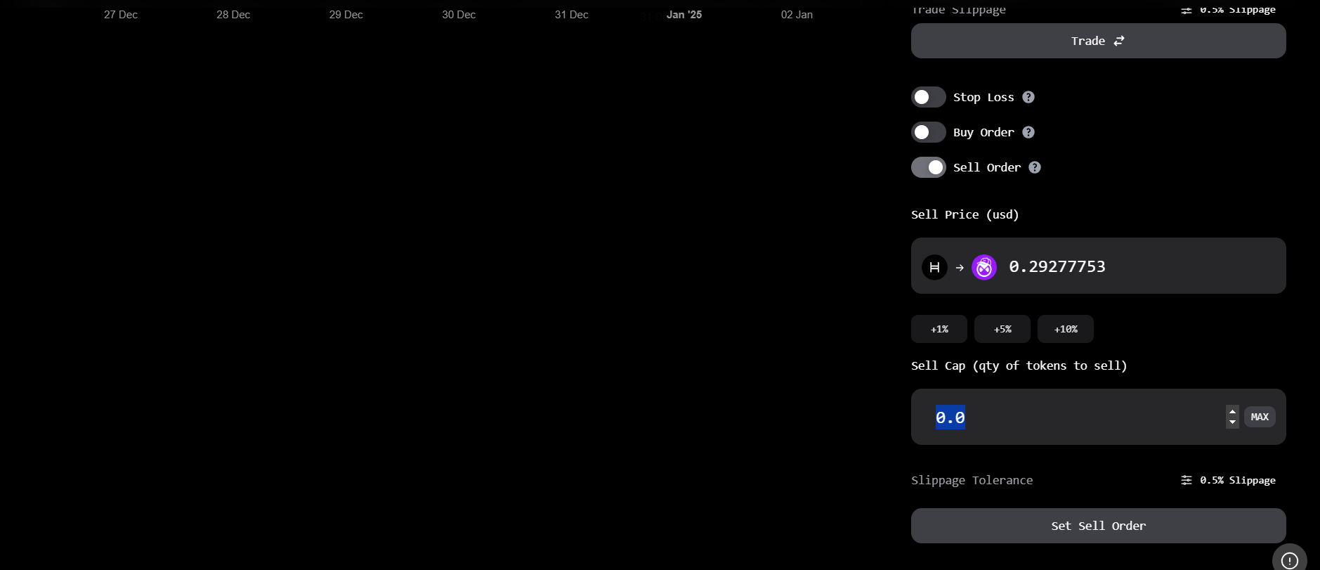

Potential:  
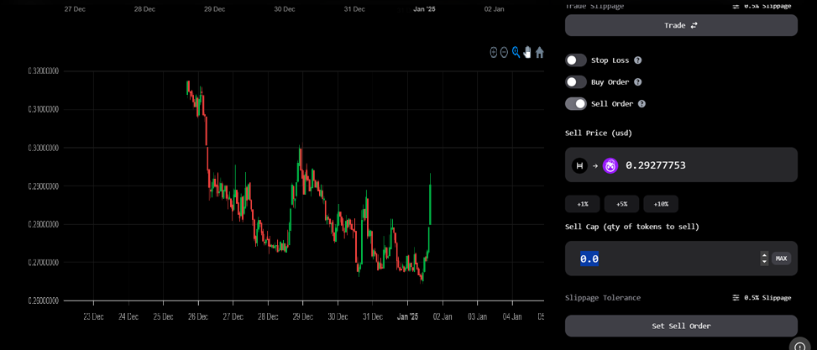

* 1. It doesn't need to, signout is asynchronous. I pushed a change yesterday so not sure if this was before or after but at the moment signing out clears the session and resets the UI. It then forwards to the landing page.
     1. Tested and this is fixed, logout button worked.
  2. this is an intended QOL feature, I'll be sure to add those checks along with proper notices
     1. Will be added
  3. the chart makes my face angry lol, I will have to swap it out again it looks nice but the zooming and moving on it is very janky
     1. Will be added
  4. I will be adding UI to change trade direction which should help, I can also make the clear button more obvious, not sure what the rest is talking about.
     1. Will be added
  5. Not understanding why this is a problem or what UX issue it aims to resolve. Seems more like a preference? I'd say lets get the dapp smooth and working while mitigating things that are confusing before we start nudging pixels.
     1. No one is going to have three options open at once, so choosing one or the other seems best. It was confusing to me and the other tech friendly user using this section.
     2. We can keep waiting on more feedback,
  6. I'll add the token names and icon to this table
     1. Will be added
  7. It seems like some confusion about howw buy orders work. I added a tooltip awhile back but maybe need to do some helper on the input too... buy orders work at equal or less than a value theres no reason to set a buy order for when its more expensive
     1. Yes, you are right that this is not how it should be used by the user, but this is how it should function. It should execute the buy order since the # put in
     2. I just did this to test the function, and it doesn’t appear to be working.
  8. sounds like a bug, shouldn't be hard to fix
     1. Will be added